Great minds: What have we learnt about neurodivergence, and what can we learn from it?

This session was hosted by Dr Amelia Draper and Katie Hall of Nottingham’s Practice Development Unit (PDU).
The slides from this session are really comprehensive and have lots of useful information so please do check them out along with the Resource Handout!
Neurodivergence is often framed as a deficit, but we recognise it as good thing – it brings diversity of thought and a variety of strengths as well as challenges – it’s a difference not a deficit. Some Common neurodivergent traits;
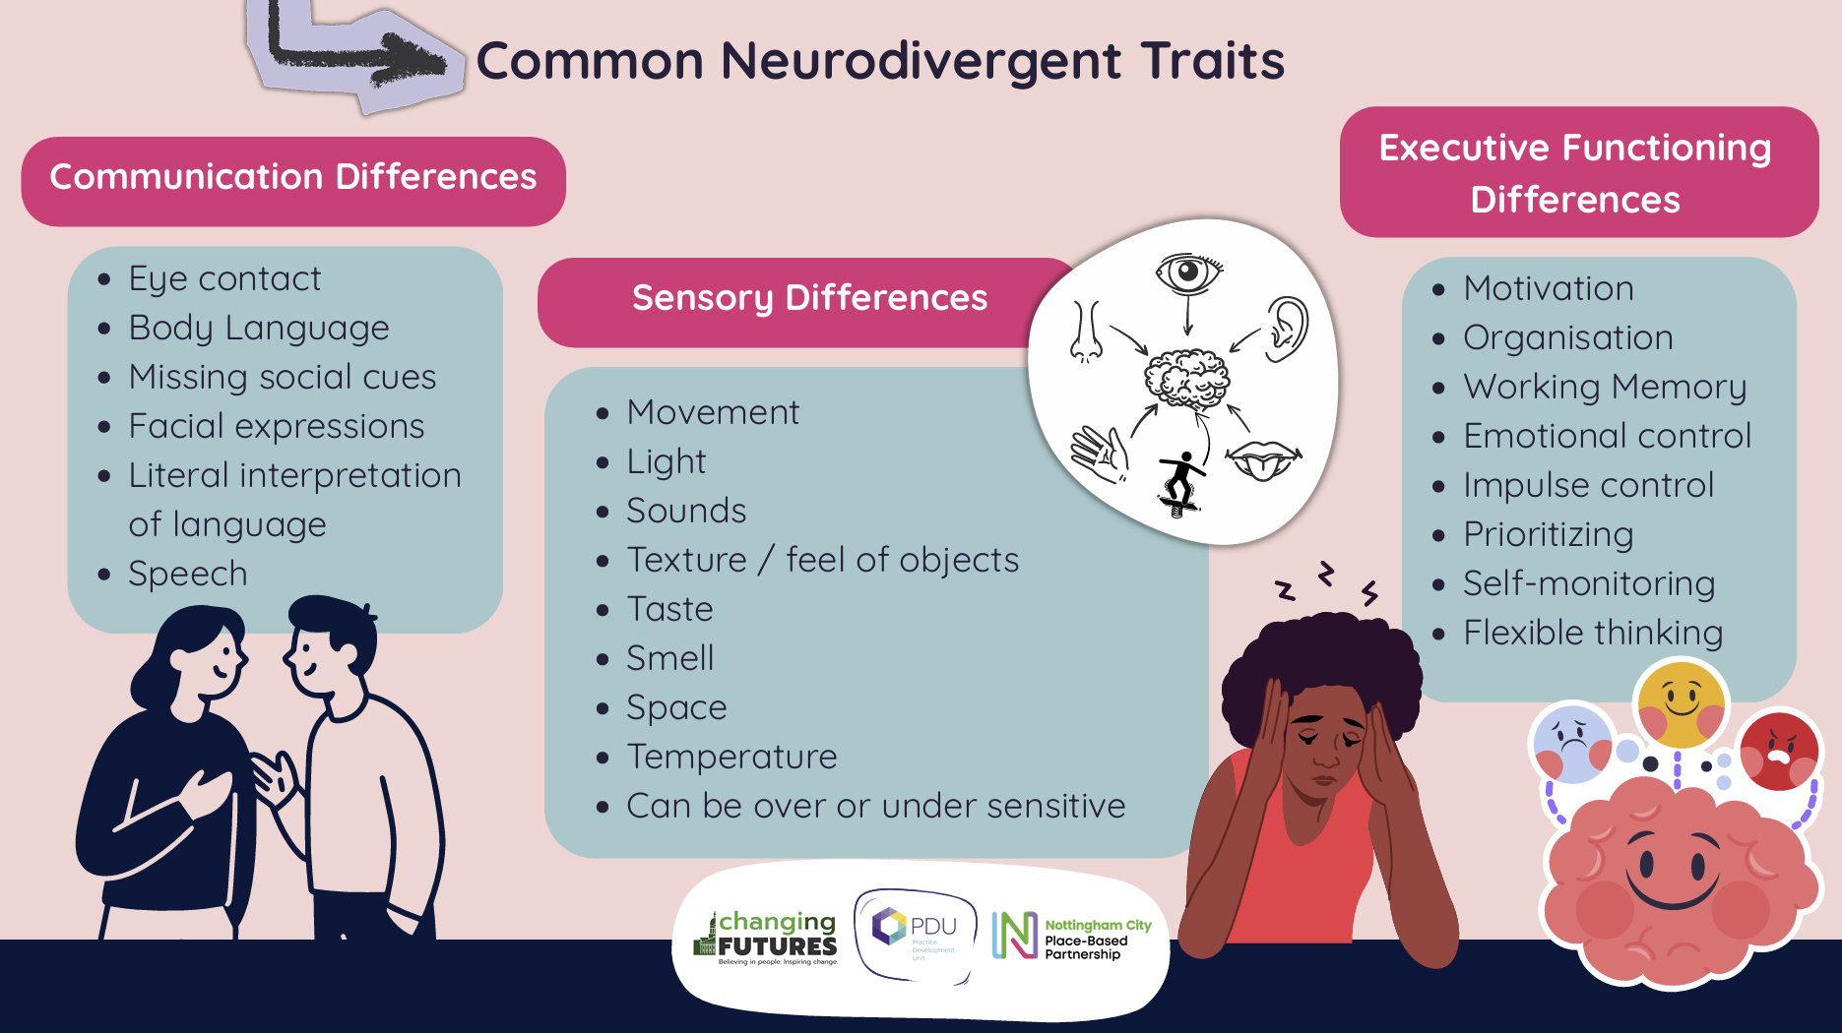
Neurodivergence is common, and it is common to have more than one co-occurring diagnosis of neurodivergence. 60% of the Changing Futures cohort in Nottingham had a neurodivergence diagnosis, but there is limited research that looks specifically at neurodivergence and multiple disadvantage.
The criminal justice system is recognising the prevalence of neurodivergence within the people they work with and are doing better in making adjustments to meet some of the sensory and communication needs. Every prison has been given a directive to address neurodivergence within its prison population but responses to this are varied.
There are questions about whether the connection between multiple disadvantage and neurodivergence is neurological or environmental but essentially what matters is meeting these differences as they are identified.
The system seems to primarily recognise trauma responses and so awareness and diagnosis around someone’s neurodivergence often does not come until later in their life. At this point, if someone has begun using substances to cope with these challenges, it then becomes harder to get them correctly assessed and diagnosed.
There are small pockets of thoughtful and innovative practice around neurodivergence and multiple disadvantage in Nottingham and beyond. In Nottingham, funding around such initiatives and research has been funded by local partnerships and it has been worth investing in developing understanding and highlighting prevalence in certain populations to centralise the need for further resources.
The PDU is running it’s SMD Neurodivergent-Affirmative Practice in Action Community of Practice on 10th June – click here to sign up!

