Co-design Readiness: Self-Assessment Tool
This self-assessment tool has been created for MEAM Approach network members and all those working in partnership to improve services and systems for people experiencing multiple disadvantage. The tool aims to guide and support conversations and to enable partnerships to consider the strengths and weaknesses of their co-design work and identify areas for further development.
Co-design is just one of many possible approaches to co-production. This tool should be read in conjunction with the MEAM resource Getting started with co-production, available on the MEAM website.
For further advice, or to enquire about bespoke support please contact Anthony Pickup, MEAM Involvement and Inclusion Manager (Anthony.pickup@meam.org.uk)

What is co-design?
Co-design is the process of collaboratively designing services with people who access services, people who deliver services and people who commission services. It is a design-led process that uses participatory methods to involve people with lived experience. There is no one-size-fits-all approach nor a set of checklists to follow. Instead, there are a series of patterns and principles that can be applied in different ways with different people.
Co-design principles are a set of values that act as a compass for projects, and help to keep teams on the same path as they move through the design process. Design principles should be specific, nuanced, and actionable.
This toolkit brings together some of the key principles and approaches that we have chosen to highlight when defining co-design, and can help partnerships assess where they are in their journey towards working co-productively.

Arnstein’s Ladder of Participation and helpful definitions
Partnerships can use Armstein’s Ladder of Participation (below left) to reflect on current practice through each stage of their self-assessment. A series of helpful definitions (below right) may also be useful to reflect on as part of the work.
Definitions:
Co-Creation: The process of engaging in both co-design and co-production.
Co-Production: Collaboratively delivering services in an equal and reciprocal relationship between service-providers, service-users and commissioners.
Co-Design: Collaboratively designing services with service-users, service-providers and commissioners.
Consultation: Seeking feedback on an intended service with the intention of making changes based on responses.
Educating: Sharing information about an intended service with no feedback sought.
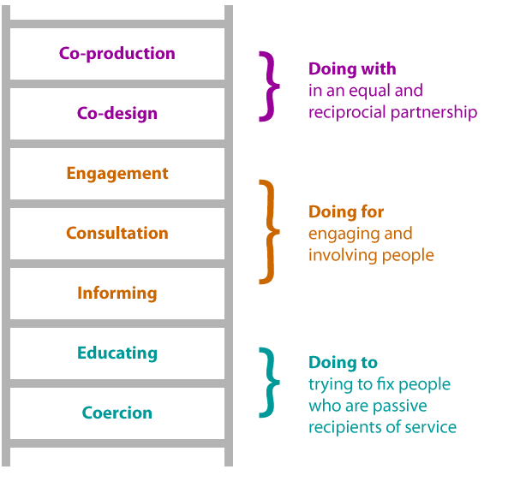
Key principles of effective co-design
Principle | Description | What is our partnership doing? | Where are we stuck? | Actions for improvement
Clarity of Purpose and Scope | - All parties must share clarity of purpose and this purpose should be coproduced.  - Clear aims and objectives should be agreed, including what is in scope for change and what is not, what is negotiable and what is not.  - Agree required and available resources.  - Agree a timeframe for the project.
Inclusiveness | - Comprehensive inclusion of all people who should benefit from the service from the beginning of the co-design process.  - Include families and carers where appropriate.  - Explore which people may not already have equitable access to services and ensure their voices are heard.  - Maximise a range of opportunities for involvement to allow different voices to be heard.  - Consider a range of communication methods to suit different needs and preferences.
Equal Partnership | - People should participate as equal partners, with shared power and decision making responsibility.  - Solutions should be focussed on what service users want/need from the service.  - Strive to build an ethos of mutual respect and trust that allows all parties to speak freely and openly.
Data Driven | - Share existing data so that all parties have equal access to information.  - Consider what information participants may need to meaningfully contribute, including data on population, community need, cohort dynamics and existing service evaluations.
On-going. | - Looking beyond the initial stages of designing and planning a new service, establish how people with lived experience will be involved in the longer- term implementation and evaluation of the service.  - Co-design should be an iterative process that allows for mistakes, learning and growth. As people gain more experience in the process, progressively the outcomes will improve, so be committed to the approach as a long term methodology.

