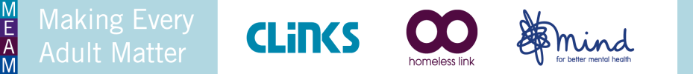
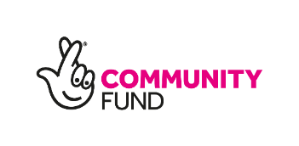
The MEAM Approach in the Midlands: Expression of Interest

The MEAM Approach helps local areas design and deliver better coordinated services for people experiencing multiple disadvantage. It’s currently being used by partnerships of statutory and voluntary agencies in 27 local areas across England.

MEAM Approach areas consider seven principles, which they adapt to local needs and circumstances. We provide hands-on support to the local partnerships as part of this process.

We currently have capacity on the team to support two new areas specifically in the East or West Midlands. Successful areas will:

- Receive “critical friend” support from MEAM staff (based regionally in Homeless Link, Clinks and Mind) as it develops its coordinated intervention
- Contribute data to a programme-wide evaluation to evidence the impact of coordinated interventions, both locally and nationally
- Benefit from shared learning hubs and networks, regionally and nationally, and engagement with the MEAM policy team
- Improve local outcomes for people facing multiple needs and develop the systemic changes that are needed to make these sustainable

To be eligible to apply, local areas must be able to:

- Resource a coordinated intervention in their area for the next three years.
- Provide data for the national evaluation for the same period
- Fully involve people with lived experience of multiple disadvantage in the design and implementation of their interventions (coproduction)
- Consider diversity and equality when identifying the cohort of people with which they wish to work
- Agree to the standard terms and conditions of MEAM and the Big Lottery Fund (these terms will be made available to shortlisted applicants)

If your area is moving towards coordinated interventions for people facing multiple disadvantage, has started to build a cross-sector partnership and is able to pool money to self-fund an intervention, then we encourage you to apply for support from the MEAM coalition.

To apply, please complete the Expression of Interest form attached below and return to r.wallbank@mind.org.uk by 31st May 2019. We ask that shortlisted areas be available for interviews (in your locality) on the 12th and 13th June 2019.

Please note that as the MEAM Approach is focused on area-wide interventions, existing Fulfilling Lives areas are not eligible to apply and we would not expect to see multiple applications from any local area.

Expression of Interest

Person completing Expression of Interest:

Name:
Position:
Organisation:
Email address:
Phone number:

About the partnership:

Which local area is making this application:
Who are the key partners in the partnership at the present time:
Please certify that you have the permission of all the partners listed to submit this form on behalf of the partnership.

Lead Partners:

Please tell us who will be the ‘lead partner(s)’ for the partnership. We note that areas with more than one ‘lead partner’ are likely to have stronger operational and strategic success.

Please tell us your initial ideas for lead partners here:

Name:
Position:
Organisation:
Email address:
Phone number:

Name:
Position:
Organisation:
Email address:
Phone number:

Name:
Position:
Organisation:
Email address:
Phone number:

- Why are you interested in working on the MEAM Approach in your area? (200 words)

- Which cohort of people do you want to improve support for by using the MEAM Approach? How have you considered equality and diversity in the identification of your cohort? (200 words)

- Do you have the beginnings of a senior cross-sector partnership in place that can oversee and “own” the work? Please provide some detail of your developing partnership. (200 words)

- Can you evidence that delivery partners across criminal justice, substance misuse, homelessness and mental health (and others) are ready to consider coordinated change at an operational level? (200 words)

- Co-production is central to the MEAM Approach. How does your area intend to involve people with lived experience of multiple disadvantage in the design and delivery of your intervention? (200 words)

- How will you and your colleagues commit time and energy over the next three years? (200 words)

- On average, existing MEAM areas have pooled funding of around £50,000 per year for their interventions. Can you tell us how your area intends to resource its coordinated intervention? (200 words)

- As a MEAM Approach area, you will be committed to engaging with and providing data for a national evaluation which will evidence the impact of your work locally as well as nationally. Can your area commit to engaging with this and how will you ensure you can share data from a range of agencies? (200 words)

- The MEAM Approach encourages and promotes shared learning across regions. How will your area participate and contribute towards learning opportunities? (200 words)

- Is there anything else you would like to add? (200 words)

Thank you for your application. Please return to: Ruth Wallbank, Midlands Partnerships Manager: r.wallbank@mind.org.uk by 31st May

