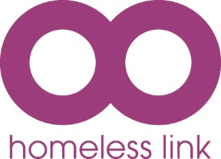
Homeless Link

DIVERSITY &

EQUAL OPPORTUNITIES

Homeless Link has an absolute commitment to diversity which is about:

■ Recognising and valuing difference
■ Recognising and seeking to redress inequality and disadvantage

In order to make our commitment a reality, we have a clear strategy, policy and plans of action to promote diversity at Homeless Link. In order to help us make our strategy effective, we ask that you assist us to monitor the outcomes of our recruitment practices by completing this form.

This form is for statistical purposes only. It will be separated from your application forms as soon as it is received and will be kept confidential.

Your form will not be seen by the recruitment panel, and will not be taken into account in deciding who will be shortlisted, interviewed or appointed. Completion of any or all of the questions is not a requirement for the application, but we would appreciate your co-operation.

By completing and returning the monitoring form which follows, you consent to Homeless Link processing this information for general monitoring purposes in line with diversity and equal opportunities policy. If you are employed, the information will be kept and used for regular internal monitoring of the diversity of Homeless Link’s staff profile against our targets.

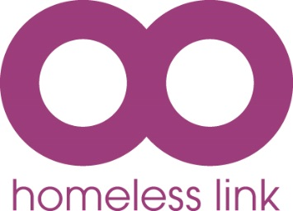
No:
Homeless Link
DIVERSITY AND
EQUALITY MONITORING FORM

Name
Date Of Birth
Post Applied For
Where did you see the vacancy advertised

For the following questions place an X in the box next to the statement which best describes you.

1. What is your ethnic origin?

A WHITE OR WHITE BRITISH |  |  | B MIXED HERITAGE
British |  |  | White & Black or Black British
Irish |  |  | White & Asian or Asian British
European |  |  | Any other Mixed background (please state)
Any other White background (please state)
C ASIAN OR ASIAN BRITISH |  |  | D BLACK OR BLACK BRITISH
Asian British |  |  | Black British
Indian |  |  | Caribbean
Pakistani |  |  | African
Bangladeshi |  |  | Any other Black background (please state)
Chinese
Any other Asian background (please state)
E ANY OTHER BACKGROUND
Any other background (please state) |  |  | Prefer not to state

- Please indicate your sex:

Male |  |  | Female
Transgender |  |  | Prefer not to state

- Do you identify as:

Lesbian/Gay |  |  | Heterosexual
Bisexual |  |  | Other
Prefer not to state

- Which religion, if any, do you follow:

Atheist |  |  | Hinduism
Agnostic |  |  | Islam
Buddhism |  |  | Judaism
Christianity |  |  | Sikhism
No Religion |  |  | Prefer not to state
Other (please state)

5. Do you identify as formerly or currently homeless?

Yes |  |  | No
Prefer not to state

If yes, have you ever:
Slept rough for longer than 6 months
Stayed in a hostel for longer than six months
Prefer not to state

- Do you identify as having a disability?

Yes |  |  | No
Prefer not to state

